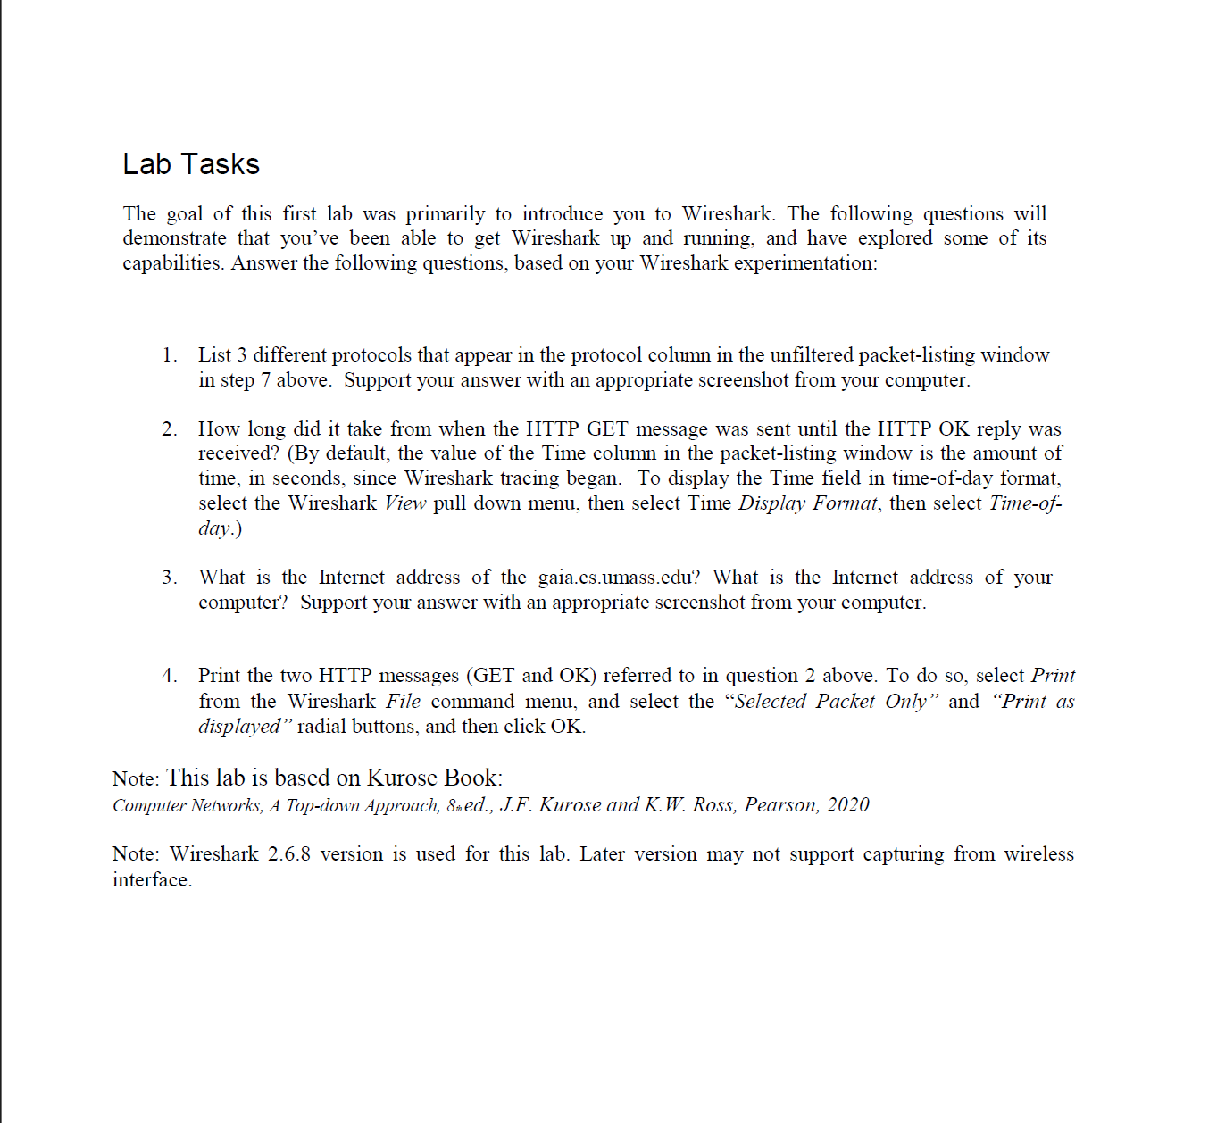  
Solutions)  
  
1) ARP, TCP,UDP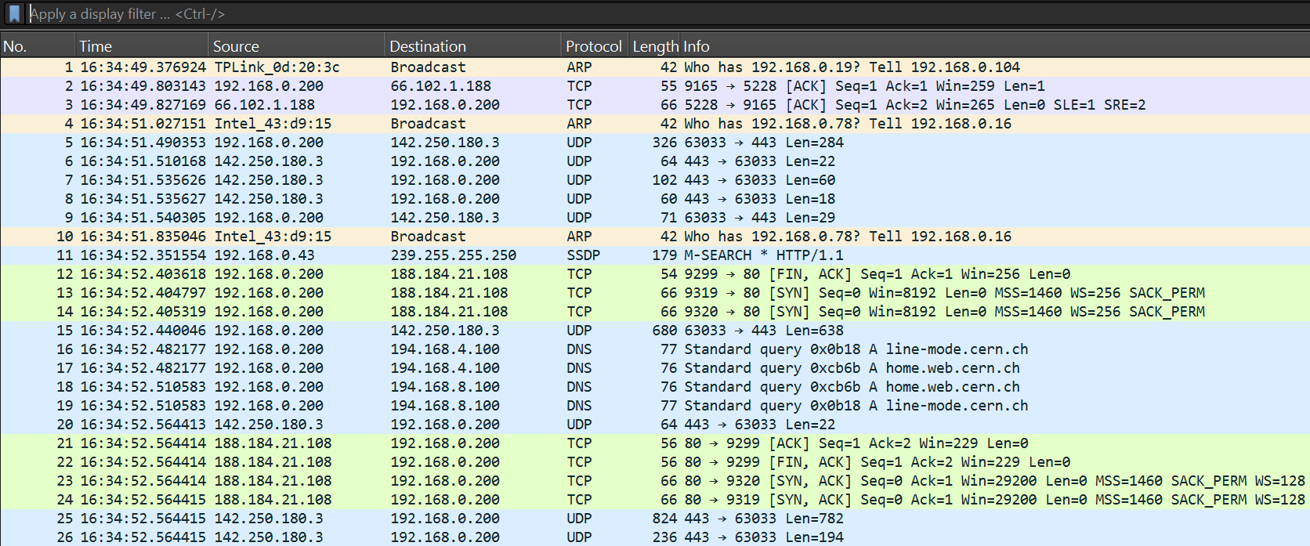  
  
2)Time difference is 0.043611  
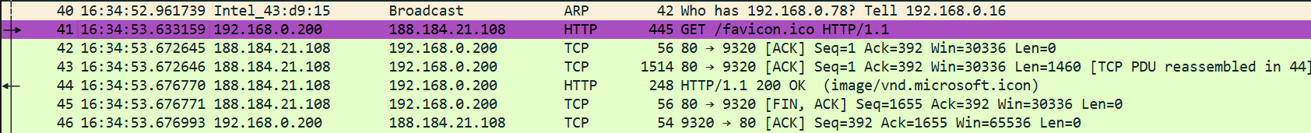

3)